DWDM EXPERIMENT-5
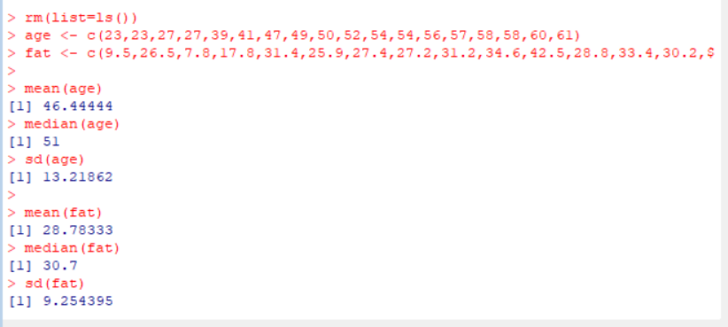
1.Console Output (Mean, Median, SD)

2. Age Boxplot
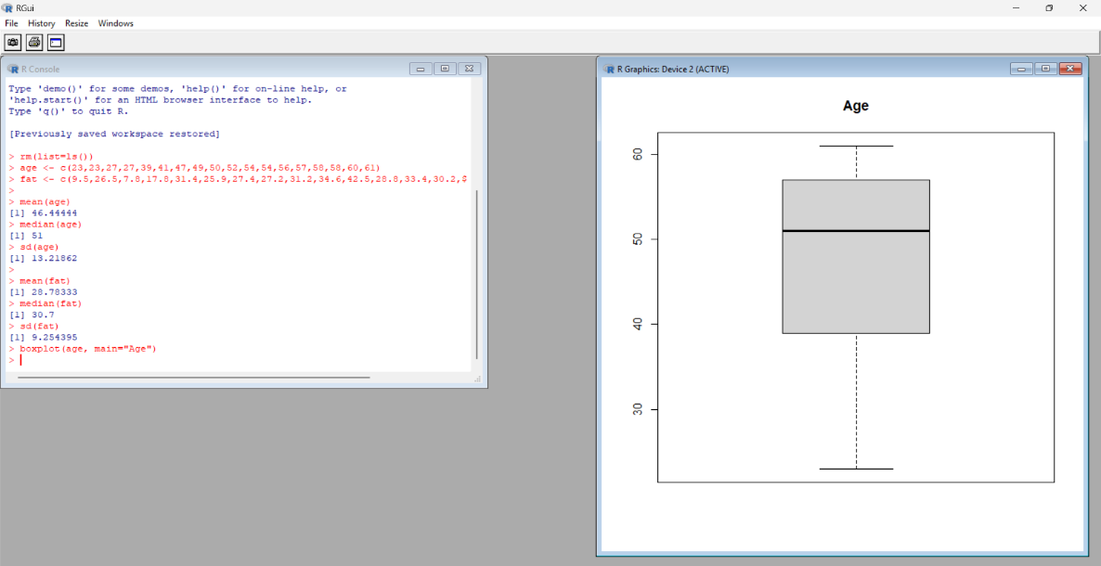

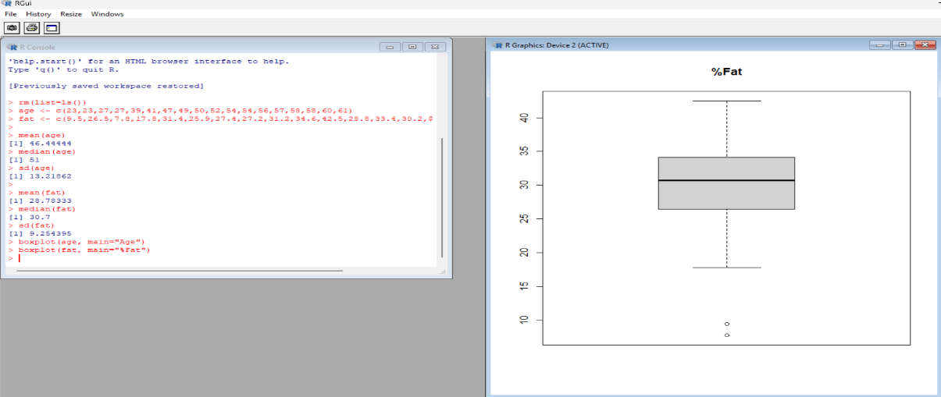
3. %Fat Boxplot

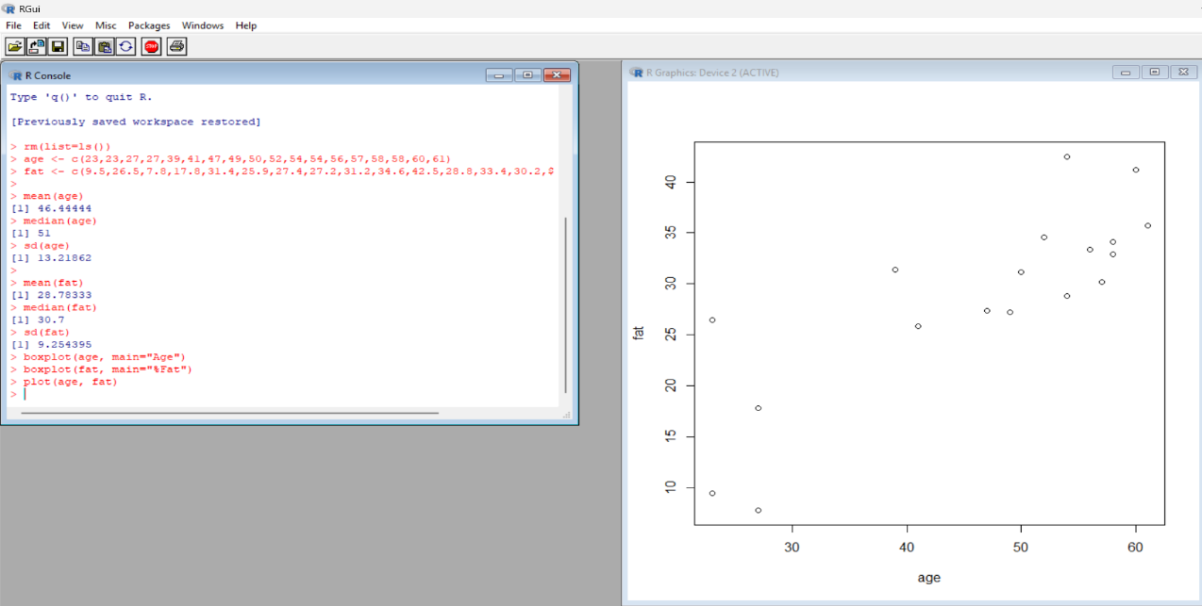
4. Scatter Plot

5. Q-Q Plot
